Name: ______________________________ AP Biology –

LAB – Diffusion and Osmosis

Objectives:
• Describe the physical mechanisms of diffusion and osmosis.
• Describe how molar concentration affects the process of diffusion.
• Predict cell outcomes when changing the concentration of solute in a solution in which the cell is suspended.
• Determine the molar concentration of sucrose in a plant cell.

Do not just copy these down for the abstract! Restate these objectives in your lab notebook in your own words!

Introduction:
Many aspects of the life of a cell depend on the fact that atoms and molecules are constantly in motion (the concept of kinetic energy). This kinetic energy results in molecules bumping into and rebounding off each other and moving in new directions. One result of this molecular motion is the process of diffusion.

Cells must move materials through membranes and throughout cytoplasm in order to maintain homeostasis. The movement is regulated because cellular membranes, including the plasma and organelle membranes, are selectively permeable. Membranes are phospholipid bilayers containing embedded proteins. The phospholipid fatty acids limit the movement of water because of their hydrophobic characteristics.

The cellular environment is aqueous, meaning that the solvent is water, in which the solutes, such as salts and organic molecules, are dissolved. Water may pass freely through the membrane by osmosis or through specialized protein channels called aquaporins. Most ions move through protein channels, while larger molecules, such as carbohydrates, are carried by transport proteins.

The simplest form of movement is diffusion, in which solutes move from an area of high concentration to an area of low concentration; diffusion is directly related to molecular kinetic energy. Diffusion does not require energy input. The movement of a solute from an area of low concentration to an area of high concentration requires energy input in the form of ATP and protein carriers called pumps.
Water moves through membranes by diffusion; this process is called osmosis. Like solutes, water moves down its concentration gradient. Water moves from areas of high potential (high water concentration) and low solute concentration to areas of low potential (low water concentration) and high solute concentration. In walled cells, osmosis is affected not only by the solute concentration but also by the resistance to water movement in the cell by the cell wall. This resistance is called turgor pressure (the physical pressure exerted on the cell).
The terms hypertonic, hypotonic, and isotonic are used to describe solutions separated by selectively permeable membranes.

• A hypertonic solution has a higher solute concentration and a lower water potential as compared to the other solution; therefore, water will move into the hypertonic solution through the membrane.

• A hypotonic solution has a lower solute concentration and a higher water potential than the solution on the other side of the membrane; water will move down its concentration gradient into the other solution.

• Isotonic solutions have equal water potential.

Name: ______________________________ AP Biology – Lab

Understanding Water Potential (ΨW)
In non-walled cells, such as animal cells, the movement of water into and out of a cell is affected by the relative solute concentration on either side of the plasma membrane. As water moves out of the cell, the cell shrinks; if water moves into the cell, it swells and may eventually burst or lyse. In walled cells, including fungal and plant cells, the presence of a cell wall prevents the cells from bursting as water enters; however, pressure builds up inside the cell and affects the rate of osmosis.

Water potential predicts which way water diffuses through plant tissues and is abbreviated by the Greek letter psi (ΨW). Water potential is the free energy per mole of water and is calculated from two major components: (1) the solute potential (ΨS) – also called the osmotic potential (sometimes shown as Ψπ) – is dependent on solute concentration, and (2) the pressure potential (ΨP), which results from the exertion of pressure — either positive or negative (tension) — on a solution.

Water Potential = Pressure Potential + Osmotic Potential

Ψw = ΨP + Ψπ
Water moves from an area of higher water potential or higher free energy to an area of lower water potential or lower free energy. Water potential measures the tendency of water to diffuse from one compartment to another compartment.

The water potential of pure water in an open beaker is zero (Ψw = 0) because both the solute and pressure potentials are zero (Ψπ = 0; ΨP = 0). An increase in positive pressure raises the pressure potential and the water potential. The addition of solute to the water lowers the solute potential and therefore decreases the water potential. This means that a solution at atmospheric pressure has a negative water potential because of the solute.

The solute potential (Ψπ) = – iCRT, where i = the ionization constant, C = the molar concentration (a.k.a. osmolarity), R = the pressure constant (R = 0.0831 liter * bars/mole * K), and T = the temperature in K (273 + °C).

A 0.15 M solution of sucrose at atmospheric pressure (ΨP = 0) and 25°C has an osmotic potential of -3.7 bars and a water potential of -3.7 bars. A bar is a metric measure of pressure and is the same as 1 atmosphere at sea level. A 0.15 M NaCl solution contains 2 ions, Na+ and Cl- (where sucrose stays as one particle); therefore i = 2, and the water potential = -7.4 bars.

When a cell‘s cytoplasm is separated from pure water (e.g. distilled water) by a selectively permeable membrane, water moves from the surrounding area, where the water potential is higher (Ψw = 0), into the cell, where water potential is lower because of solutes in the cytoplasm (Ψw is negative). It is assumed that the solute is not diffusing (Figure 1a). The movement of water into the cell causes the cell to swell, and the cell membrane pushes against the cell wall to produce an increase in pressure. This pressure, which counteracts the diffusion of water into the cell, is called turgor pressure.

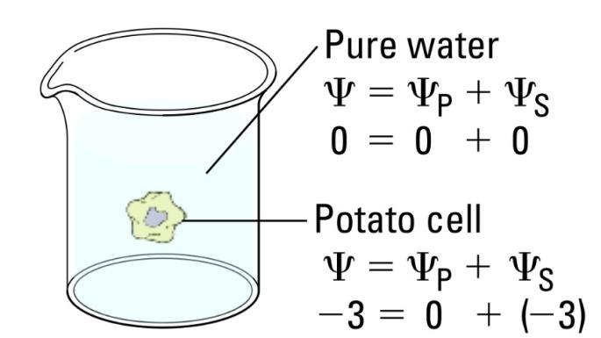
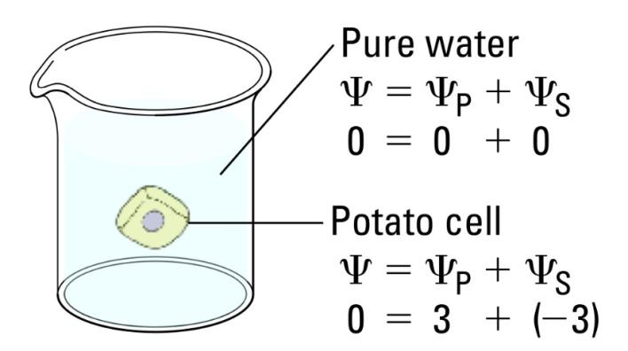
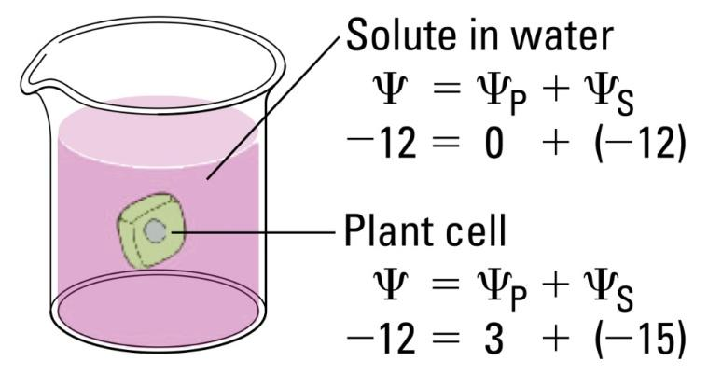
Name: ______________________________ AP Biology – Lab

Over time, enough positive turgor pressure builds up to oppose the more negative solute potential of the cell. Eventually, the water potential of the cell (not just osmotic potential!) equals the water potential of the pure water outside the cell (Ψw of cell = Ψw of pure water = 0). At this point, a dynamic equilibrium is reached and net water movement ceases (Figure 1b)

Figures 1a-b: Plant cell in pure water. The water potential was calculated at the beginning of the experiment (a) and after water movement reached dynamic equilibrium and the net water movement was zero (b).

If solute is added to the water surrounding the plant cell, the water potential of the solution surrounding the cell decreases. If enough solute is added, the water potential outside the cell is then equal to the water potential inside the cell, and there will be no net movement of water. However, the solute concentrations inside and outside the cell are not equal because the water potential inside the cell results from the combination of both the turgor pressure (ΨP) and the solute pressure (Ψπ), as shown in Figure 2.

Figure 2: Plant cell in an aqueous solution. The water potential of the cell equals that of surrounding solution at dynamic equilibrium. The cell’s water potential equals the sum of the turgor pressure potential plus the solute potential. The solute potentials of the solution and of the cell are not equal.
If more solute is added to the water surrounding the cell, water will leave the cell, moving from an area of higher water potential to an area of lower water potential. The water loss causes the cell to lose turgor pressure. A continued loss of water will cause the cell membrane to shrink away from the cell wall, and the cell will plasmolyze.

Name: ______________________________ AP Biology – Lab

Prelab questions: (copy this question and your solution, showing all work, in your lab notebook)
- Calculate the solute potential of a 0.1 M NaCl solution at 25°C.

- If the concentration of NaCl inside the plant cell is 0.15 M, which way will the water diffuse if the cell is placed into the 0.1 M NaCl solution? HINT: Draw a diagram like Figure 2.

This concept can be reviewed on pages 597-598 in your textbook.

This investigation consists of two parts. In Procedure 1, you will create models of living cells out of selectively permeable dialysis tubing to explore the rate of osmosis under different sized osmotic gradients, and use your results to identify the concentration of sucrose in each colored solution. Students finish by observing osmosis in Procedure 2 by using living cells to determine the osmolarity of carrot cells, and use this information to calculate the water potential of a carrot cell.

Name: ______________________________ AP Biology – Lab

Procedure:

Procedure:
PART I – Effects of Osmotic Potential Differences Across a ‘Membrane’ 1. Obtain six, ~20 cm strips of pre-soaked dialysis tubing.
2. Tie off one end of each piece as you would a water balloon.
3. Pour about 10 mL (three droppers full) of each of the colored solutions into separate bags.
4. Remove some of the excess air from each bag and tie off as you would a water balloon.
5. Carefully blot the outside of each bag and record the initial mass of each bag in your notebook in a data table.
7. Place each bag in one of three 250 mL beakers (or plastic cups) and fill with 200 mL of tap water. Label each beaker with your group number.
8. Let stand for 30 minutes, then remove the bags and carefully blot each.
9. Determine the mass of each bag and record in your lab notebook in the data table.
10.Record data of percent change in mass in the class data table (on the class computer as well).
11.Using the spreadsheet, incorporate onto a graph the mean, standard deviation, and error bars of the class results.
(HINT: http://www.uvm.edu/~jleonard/AGRI85/spring2004/Standard_Error_Bars_in_Excel.html)

Results: PART I
Dialysis Bag – Individual Group Data – copy this into your lab notebook

Contents of beaker | Initial Mass | Final Mass | Mass Difference | % Change in Mass*
0.0M sucrose
0.2M sucrose
0.4M sucrose
0.6M sucrose
0.8M sucrose
1.0M sucrose

*Percent Change in Mass =
(Final Mass) – (Initial Mass)
Initial Mass

X 100

Name: ______________________________ AP Biology – Lab

Dialysis Bag – Class Data

 | Percent Change in Mass of Dialysis Bags |  |  |  |  |  |  |  | Mean |  | Standard Deviation |  | SEM
 | Group 1 | Group 2 | Group 3 | Group 4 | Group 5 | Group 6 | Group 7
red
orange
yellow
green
blue
purple

Identify which color solution is which of the following concentrations: 0M, 0.2 M, 0.4 M, 0.6 M, 0.8 M and 1.0 M sucrose

Name: ______________________________ AP Biology – Lab

Procedure:
PART II – Determining the Osmolarity of Different Apples
1. Obtain twelve baby carrots. Mass two at a time and place in a plastic cup or beaker (total of six cups). Record masses of each pair of carrots in a data table in your lab notebook.
2. Add a different colored solution to each beaker, add just enough to completely cover the carrots.
3. Cover the beakers with plastic wrap and place on a cafeteria tray.
4. Let stand until next class meeting.
5. The next class meeting, record the temperature of the sucrose solutions in your lab notebook.
6. Remove the carrots from one of the beakers, blot them gently on paper towel and determine their combined mass. Do the same for your other beakers.
7.Record the final masses and calculate percent change in the data table in your lab notebook.

Results: (PART II)
Carrot Results

Contents of beaker | Temperature | Initial Mass | Final Mass | Mass Difference | % Change in Mass¶
0.0M sucrose
0.2M sucrose
0.4M sucrose
0.6M sucrose
0.8M sucrose
1.0M sucrose

¶Percent Change in Mass =
(Final Mass) – (Initial Mass)
Initial Mass

X 100

Name: ______________________________ AP Biology – Lab

In your lab notebook, construct a graph of percent change in mass (Y-axis, your dependent or responding variable) vs. concentration of sucrose (X-axis, your independent or manipulated variable). The X-intercept of your graph will provide an estimate of the molarity of a carrot cell (in other words, the concentration of a sucrose solution which would result in a 0% change in mass of the carrot cells)

Once you have an estimate of the molarity of a carrot cell, use this concentration and the temperature of the solutions to calculate the water potential of a carrot cell. Show your work in your lab notebook!!

Make sure you lab notebook contains at LEAST all of the following:
- Objectives of this lab in your own words
- Answers to prelab questions (two questions)
- Results (All data tables and graph plus calculation of water potential of a carrot cell showing all work and units)
  - Your dialysis bag data table
  - Class dialysis bag data table with means, standard deviation and SEM (refer to google doc)
  - Your carrot data table
  - Class carrot data table with means, standard deviation and SEM (refer to google doc)
  - Graph of means (with 95% confidence intervals) from class carrot data table
  - What is the estimate of the molarity of a carrot cell from your graph? Use this estimate to calculate the water potential of a carrot cell, show ALL of your work and units

